APARTMENT MAINTENANCE REQUEST PORTAL
@CREATIVITY THINK (9483175986/7019689991)

ABSTRACT:
The Apartment Maintenance Request Portal is a dynamic web-based application designed to streamline maintenance ticket submission, tracking, communication, and reporting within residential apartments, gated communities, and office buildings. The system enables residents to raise issues with priority, category, and photos, while receiving real-time status updates and notifications. Administrators can assign tasks to staff, configure SLA rules, broadcast alerts, and export monthly analytics. The portal ensures transparency, reduces delays, enhances communication between residents and staff, and improves overall operational efficiency..

INTRODUCTION OF THE PROJECT:
Maintenance management in apartments and large communities often suffers from delays, lack of communication, and poor tracking of issues. Manual processes such as phone calls, handwritten logs, or WhatsApp-based reporting lead to missed requests and inefficient documentation.
The Apartment Maintenance Request Portal modernizes this workflow by providing a unified digital platform where residents can raise maintenance complaints, upload images, track progress, and communicate with staff in real time. Admins can manage priorities, assign workers, monitor SLA deadlines, and generate analytical reports to improve maintenance performance..

PROJECT OBJECTIVES:

• Allow residents to raise maintenance tickets with category, priority, and photos
• Provide real-time status tracking for tickets (open / in-progress / closed)
• Enable in-app notifications for updates and communication
• Support chat between resident and maintenance staff
• Maintain ticket history and analytics charts
• Allow admins to configure categories, priorities, and SLA timing
• Provide assignment workflow for staff and supervisors
• Broadcast outage or notice alerts to all residents
• Export monthly reports in CSV/PDF formats
• Improve transparency and reduce complaint resolution delays

PROBLEM OF THE STATEMENT:
Traditional maintenance request handling—via phone calls or manual registers—is inefficient and lacks transparency. Residents cannot track complaint status, staff assignments are unclear, and communities face delays in issue resolution. There is also no reliable method to analyze monthly maintenance performance or SLA compliance.
This portal solves the problem by digitizing the entire process, ensuring structured complaint handling, real-time updates, and data-driven reporting..

MOTIVATION OF THE PROJECT:
• Need for reliable and trackable maintenance communication
• Reduce delays caused by manual processes
• Improve communication between residents and maintenance staff
• Provide transparency for residents through real-time tracking
• Enhance community operations with analytics and SLA insights
• Reduce workload on community managers via automation
• Build a centralized and easily accessible digital platform

BLOCK DAIGRAM OF PROJECT:

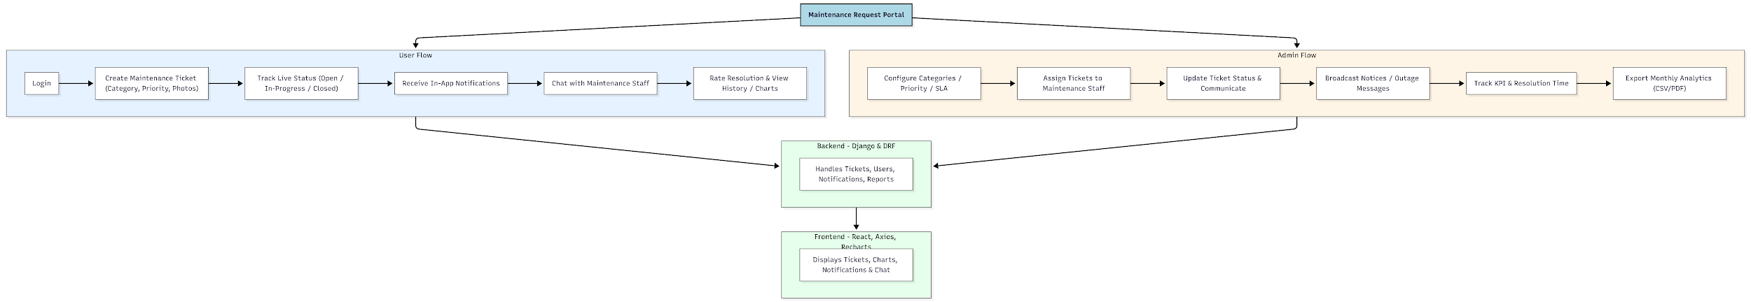

WORKING OF THE PROJECT:
Residents log into the portal and raise maintenance tickets by selecting a category, priority, and optionally uploading images. The system assigns the ticket to the appropriate staff based on admin rules. Users can view status updates in real time, receive notifications, and communicate through an in-app chat.
Admins manage categories, priorities, SLA timings, and assign staff to each ticket. They can broadcast urgent notices such as water outages or maintenance shutdowns. The dashboard provides analytics on ticket resolution times, staff performance, and monthly trends. Admins can export reports in CSV or PDF format for documentation and auditing..

SOFTWARE REQUIREMENT:
- Backend:
  - Python 3.x
  - Django
  - Django REST Framework
  - SQLite/PostgreSQL
- Frontend:
  - Node.js and npm
  - React.js
  - Axios
- Development Tools:
  - Visual Studio Code
  - Postman (for testing APIs)
  - Git/GitHub (for version control)
- Server/Deployment (Optional):
  - Gunicorn, Nginx, or Heroku/AWS for hosting

ADVANTAGES OF THE PROJECT:

• Fast and transparent ticket handling
• Real-time notifications and updates
• Easy communication through built-in chat
• SLA-based tracking improves staff performance
• Analytics dashboard for community managers
• Easy export of monthly maintenance reports
• Reduces manual workload and delays
• Enhances resident satisfaction and convenience

APPLICATIONS OF THE PROJECT:
• Residential apartments
• Gated communities
• Housing societies
• Office buildings
• Community management companies
• Maintenance and facility management teams

REFERENCES:

- Django REST Framework Documentation — Django Software Foundation. Django Documentation. Available: https://docs.djangoproject.com/
- Django REST Framework. DRF Documentation. Available: https://www.django-rest-framework.org/
- React. React Official Documentation. Available: https://reactjs.org/docs/getting-started.html
- Redux. Redux Documentation. Available: https://redux.js.org/introduction/getting-started
- PostgreSQL Global Development Group. PostgreSQL Documentation. Available: https://www.postgresql.org/docs/
- MySQL. MySQL Reference Manual. Available: https://dev.mysql.com/doc/
- Git. Git Documentation. Available: https://git-scm.com/doc
- Node.js. Node.js Documentation. Available: https://nodejs.org/en/docs/
- Axios. Axios Documentation. Available: https://axios-http.com/docs/intro
- Socket.io Documentation – https://socket.io/docs/

